Grand canyon
Helicopter, Nature, Hiking, Desert, Vegas

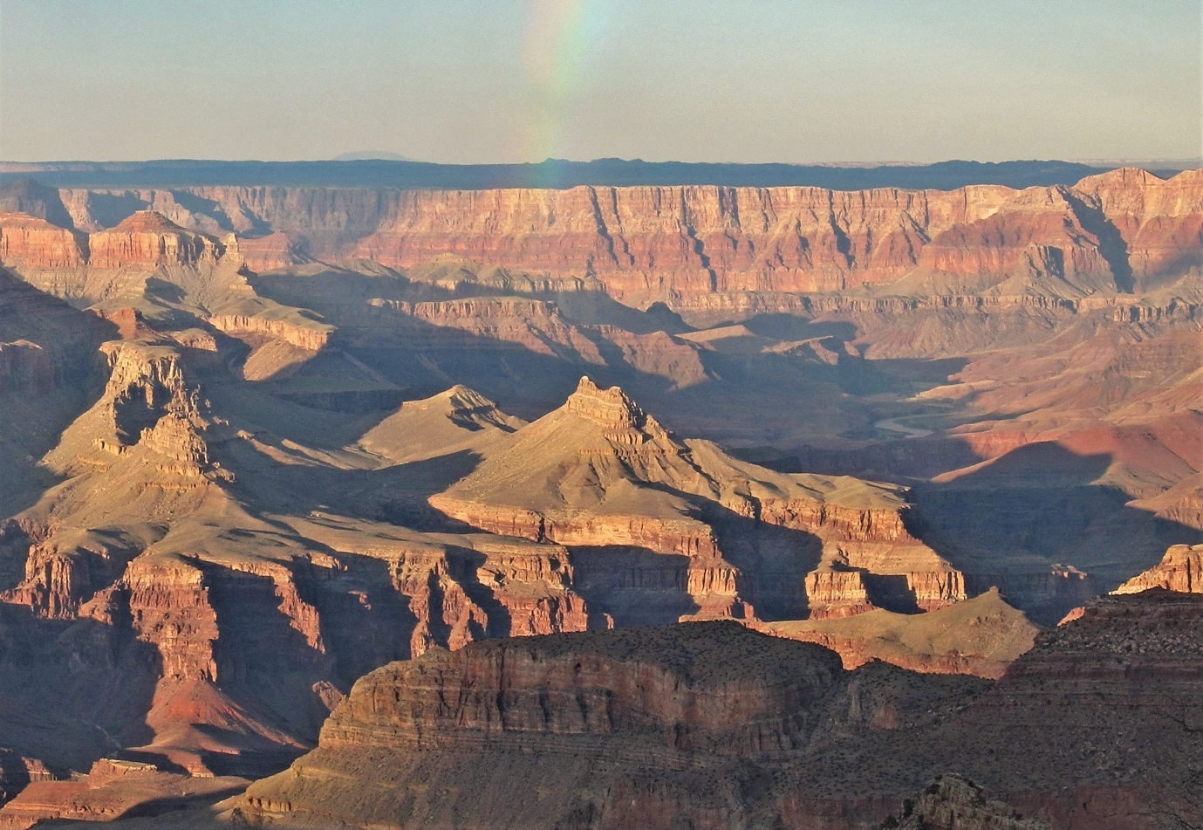

By Grand Canyon National Park NPS Photo by Michael Quinn - File:Grand Canyon National Park Grandview Point Sunset 0175 (6173461875).jpg, CC BY 3.0, https://commons.wikimedia.org/w/index.php?curid=99124931

For some, the freedom and the desert sunsets are ample entertainment. But for the thrill-seekers if 277 miles length, 18-mile width and the North Rim’s Point Imperial at 8,803 won’t suffice then quad bikes and jeeps cruise, hikers go off-road, skydivers plunge and soaring helicopter rides sweep low over the Colorado River, the kayaking white-water rafting and fishing playground that scythes through the landscape like a snake. Elk, Skunks, Ringtails, Bighorn Sheep and Mountain Lions roam the wilds of this wonder of the natural world.
Walk the ‘Trail Of Time’ where markers show rock layer growth by the millions of years. Discover the fossil beds of Hermit’s Trail. You’ll find vertigo-inducing see-though floors of the Skywalk in Grand Canyon West. Quiet solitude and beautiful walks are easy to find, like the paved 13-mile Hermit’s Rest to South Kaibab trailhead route.
Phone apps deliver info from park rangers on the area’s various sites. Desert View Visitor Centre and Tusayan ruins teach of Pueblo Indians, inhabitants of the area’s sometimes daunting conditions for hundreds of years.

Testing oneself and pushing boundaries come easy in Northwest Arizona’s Grand Canyon. The world famous semi-arid landscape of soaring peaks and plummeting drops, forged by 5-6 million years erosion by the turquoise and white sprays of the Colorado River offers the spirituality of connecting with nature, adventure galore and countless opportunities for relaxation.

Time to visit
Spring March – May smaller crowds, good weather and clear skies. Summer months July to September is best for weather, crowds are high though. North Rim is closed during winter so avoid if you want north Rim, less crowds however.

Area to stay
Grand Canyon Village, located inside the national park for good hotels and proximity to attractions. Tusayan for good shopping / amenities & very close to the park. Flagstaff, slightly further away great on a budget.

